# JS Advanced Exam

# Problem 1. Scary Story

**Environment Specifics**

Please be aware that every JS environment may **behave differently** when executing code. Certain things that work in the browser are not supported in **Node.js**, which is the environment used by **Judge**.

The following actions are **NOT** supported:

* **.forEach()** with **NodeList** (returned by **querySelector()** and **querySelectorAll()**)
* **.forEach()** with **HTMLCollection** (returned by **getElementsByClassName()** and **element.children**)
* Using the **spread-operator** (**...**) to convert a **NodeList** into an array
* **append()** in Judge (use only **appendChild()**)
* **prepend()**
* **replaceWith()**
* **replaceAll()**
* **closest()**
* **replaceChildren()**
* Always turn the collection into a **JS array** (forEach, forOf, et.)

If you want to perform these operations, you may use **Array.from()** to first convert the collection into an array.

**Use the provided skeleton to solve this problem.**

**Write the missing functionality** of this user interface. The functionality is divided in the following steps:

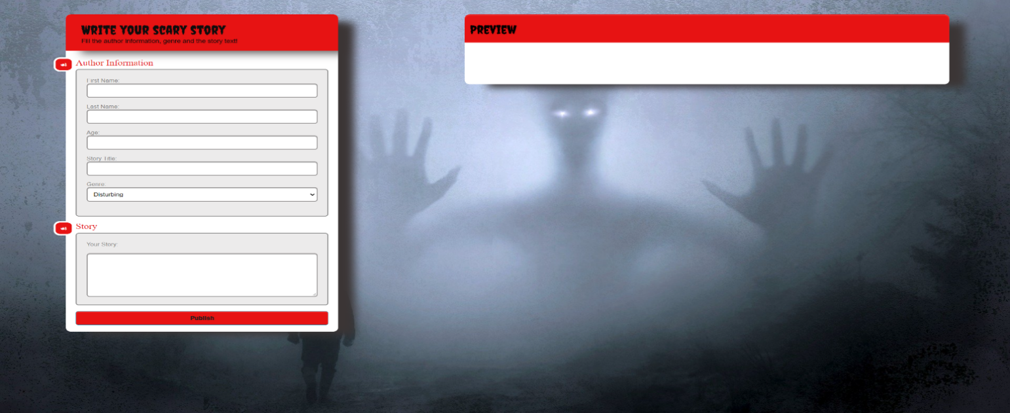**Your Task**

**Write the missing JavaScript code** to make the **Scary Story** work as expected:

All fields **(First Name, Last Name, Age, Genre, Story title** and **Story text)** are **filled with the correct input**

* **First Name, Last Name, Age, Story title** and **Story text** are **non**-**empty** **strings**. If any of them is empty, the program should not do anything.

1. **Getting the information from the form**

## 

* On clicking the [“Publish”] button the information from the input fields is listed in the **"**preview" section. For the input fields a **list item** is **added** to the **"**preview-list" unordered list.
* The text format and order for each list item should be the same as on the picture below.
* When the button is clicked, the input fields must be cleared and the ["Publish"] button must be **disabled**. At the same time the "Save", "Edit" and the "Delete" buttons must be **enabled**.

The HTML structure looks like this:

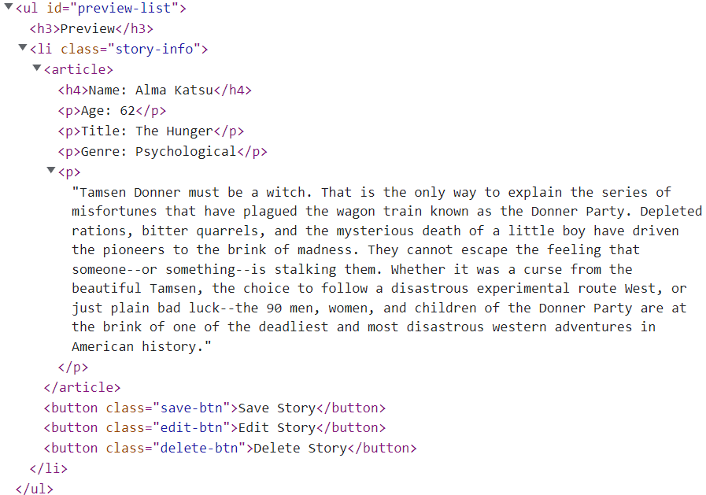

**The functionality here is the following:**

* **When the "**Edit" **button is clicked, all of the information is loaded in the input fields from step 1 and all buttons in preview section are disabled while the** ["Publish"] **button is enabled again.**

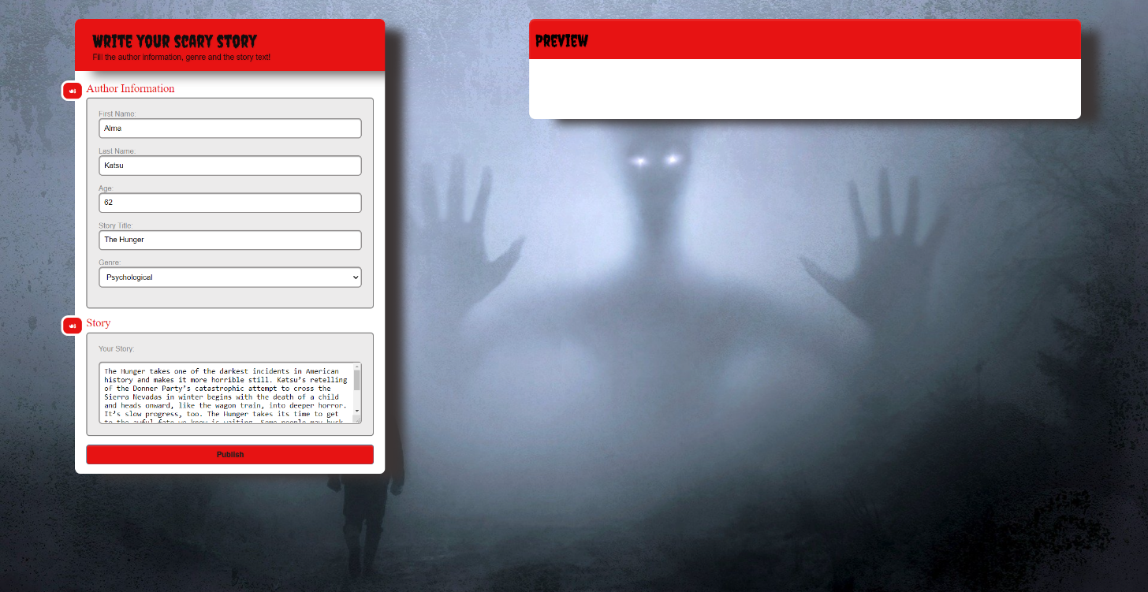

* **The list items must be removed from the** "preview-list" and **all of the information must go back to the input fields again**.

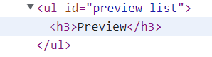

* **When the** "Save" **button is clicked,** **the story is completed. For you, this means removing everything inside of the div with id =** "main" **and adding there only a <h1> tag. With message: "Your scary story is saved!"**

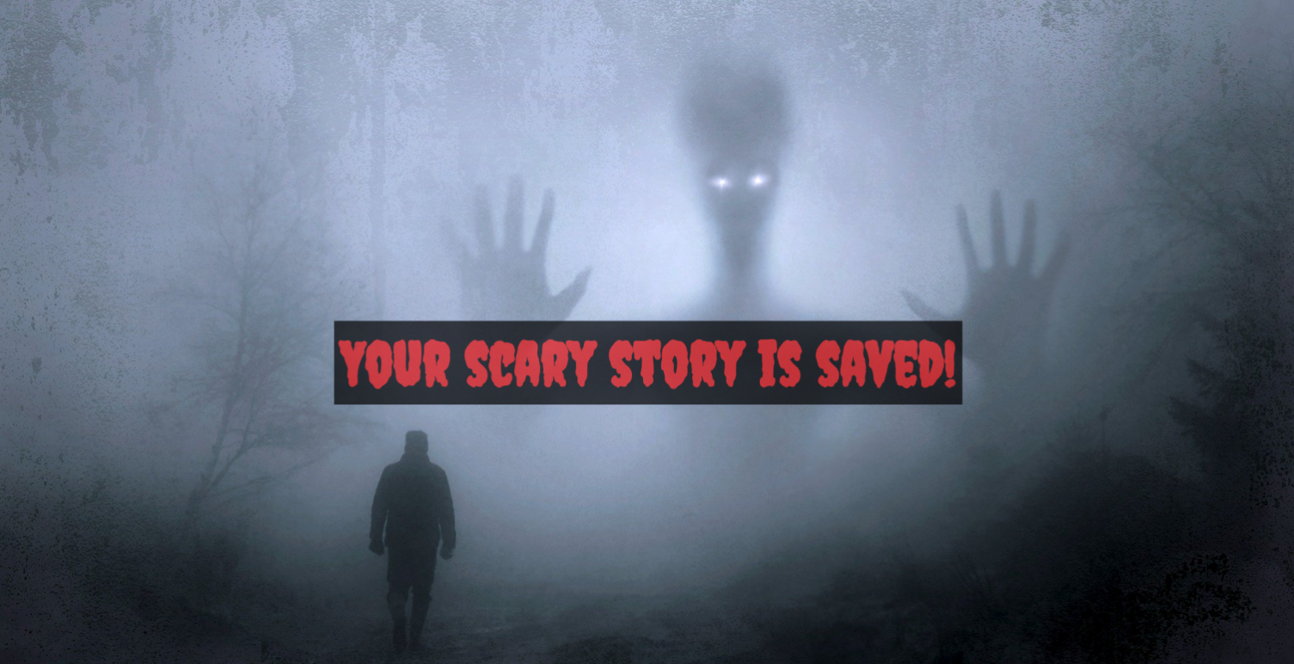

* **This is everything your webpage must contain at this step:**

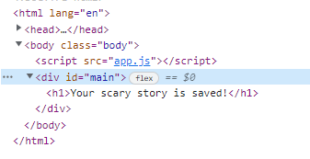

* **When the** "Delete" **button is clicked,** **the list item must be removed from the** "preview-list" **and the** ["Publish"] **button is enabled again**.



# Submission

Submit only yours **solution()** function.

*GOOD LUCK… ☺*